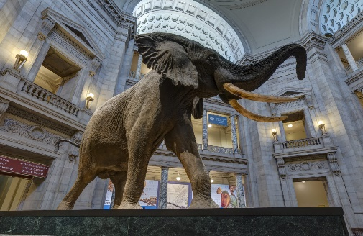

Smithsonian Museum of Natural History

SCAVENGER HUNT

# Your Team

|  |  |
| --- | --- |
| Team Name: |  |
| Who is on your team? |  |

# The Nitty Gritty

* Go through the [Virtual Tour](https://naturalhistory2.si.edu/vt3/NMNH/z_tour-022.html) and answer as many questions as you can from the sheet below in the allocated time.
* Create a private meeting for your team and share a copy of this document, preferably where you can all co-edit.
* NO CHEATING! As in finding answers outside of the museum virtual tour.
* Take the first few minutes to explore the museum and familiarize yourself with the different areas. As you explore, you’ll become more efficient at identifying where to find certain objects.

# Museum Tour Details

* The virtual tour allows you to look all around (so do look up) and zoom closer on exibits, which you will need to read some labels required to answer questions. NOTE that depending on your internet connection speed, you might have to wait a second or two for the higher resolution image to load. General guidance is that if a plaque is not readable then it was not used to answer a question.
* The virtual museum is composed of 3 levels, with multiple Halls (large open spaces) and Virtual Viewpoints (dots on the map you can click to put your avatar. All of it is accessible with a map in the upper right-hand corner.

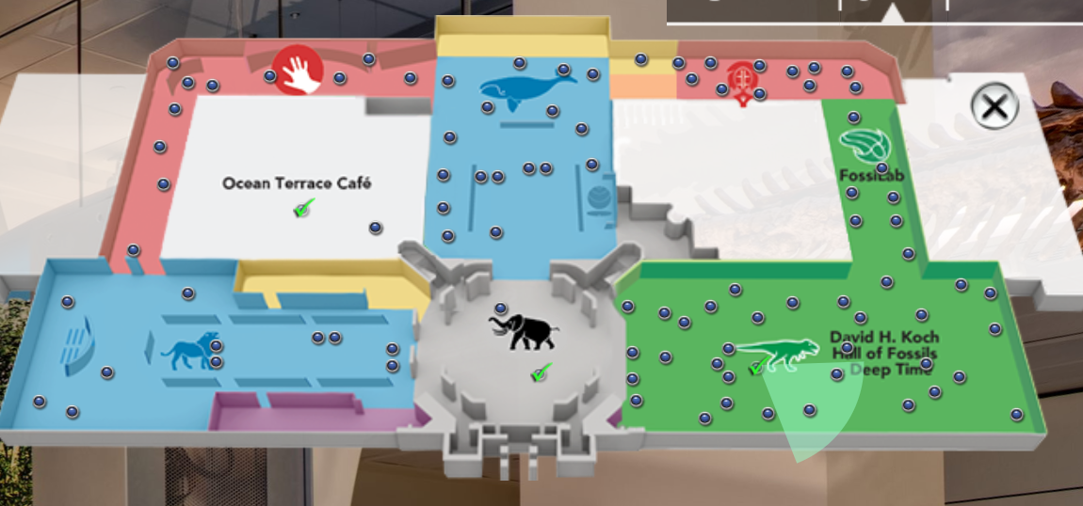

* On the bottom there is a navigation tool bar which will tell you the Hall and Virtual View Point you currently occupy. Hence in the picture below ‘Mammal Hall’ is the hall name and ‘North America 2’ is the Virtual Viewpoint. These are important in answering some questions.

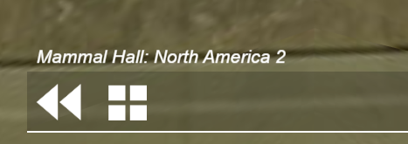

* + Questions that ask you to take a picture can be answered by taking a snapshot of your browser. On windows this can be done with the [Windows Snipping Tool](https://www.youtube.com/watch?v=O_55eg00H-w) and pasted into the document (make sure to use the ‘in line with text’ in Office Word to avoid weird alignment).

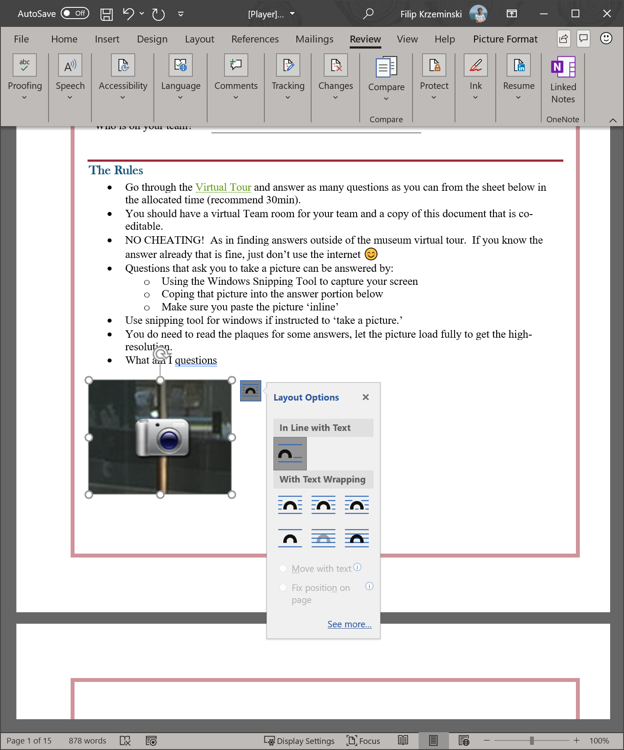

* + It’s also recommended to note down the Hall and Room where the pic was taken.
* Throughout the exhibits there are ‘camera’ icons that allow you to click for a closer look. Make sure you do 😊

Questions

# Question 1 [5pts]

|  |  |
| --- | --- |
| Which part of the museum do I hang out at? |  |

# Question 2 [5pts]

|  |  |
| --- | --- |
| Take a picture of a T-Rex eating a Triceratops. |  |

# Question 3 [15pts]

|  |  |
| --- | --- |
| What practice in ancient Egypt pushed some animal species to near extinction?  Hint: |  |

# Question 4 [10pts]

Take a picture of a Koala.

# Question 5 [10pts]

|  |  |
| --- | --- |
| What kind of sculpture is this? |  |

# Question 6 [15pts]

|  |  |
| --- | --- |
| Name one distinct feature of insects from the ‘class crustacea’. |  |

# Question 7 [15pts]

|  |  |
| --- | --- |
| Take a picture of a Feather Star. |  |

# Question 8 [35pts]

|  |  |
| --- | --- |
| What is my favorite letter? |  |

# Question 9 [40pts]

|  |  |
| --- | --- |
| What does “05-01” hold? |  |

# Question 10 [30pts]

|  |  |
| --- | --- |
| Take a picture of a REAL mommy. |  |

# Question 11 [10pts]

|  |  |
| --- | --- |
| How many spores does an average-size Fern leaf produce? |  |

# Question 12 [80pts+40pts]

Take a picture (or compose one) of your whole team at the museum!

Bonus 20pts for the most convincing.

Bonus 20pts for the most fun & creative.

# Question 13 [5pts]

Three animals, two meals, one fossil. Name two of the three animals.

Hint:

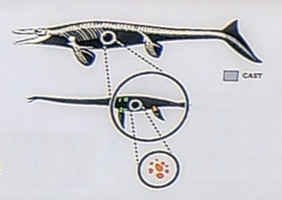

# Question 14 [10pts]

How long ago did the American mastodon live?

# Question 15 [20pts]

New Jersey has two of the worlds most unusual mines, with one of them producing as much as ___ unique mineral deposits.

# Question 16 [30pts]

What monster snake lived in ancient Colombia and was 48 ft long? Give a name and take a picture.

# Question 17 [60pts]

I weigh “less then a spoon of sugar”.

# Question 18 [5pts]

What am I?

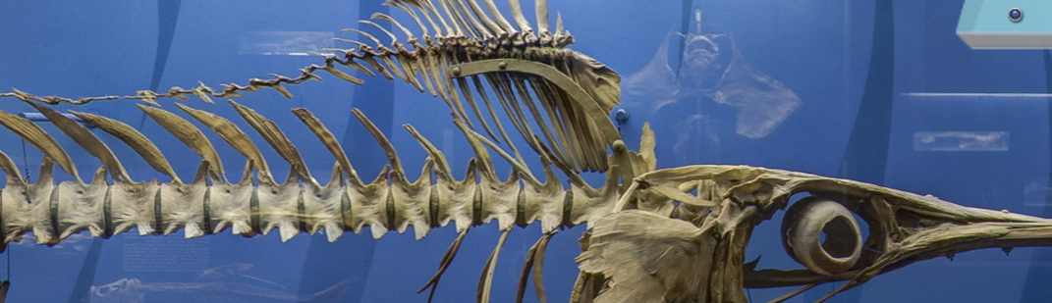

# Question 19 [15pts]

What is the fastest mammal in North America?

# Question 20 [15pts]

Fill in the blank:

“A passion for discovery leads scientists to extraordinary places, from _____ feet below the ocean’s surface to the edge of active volcanoes.”

# Question 21 [15pts]

What hall of the museum do I live in?

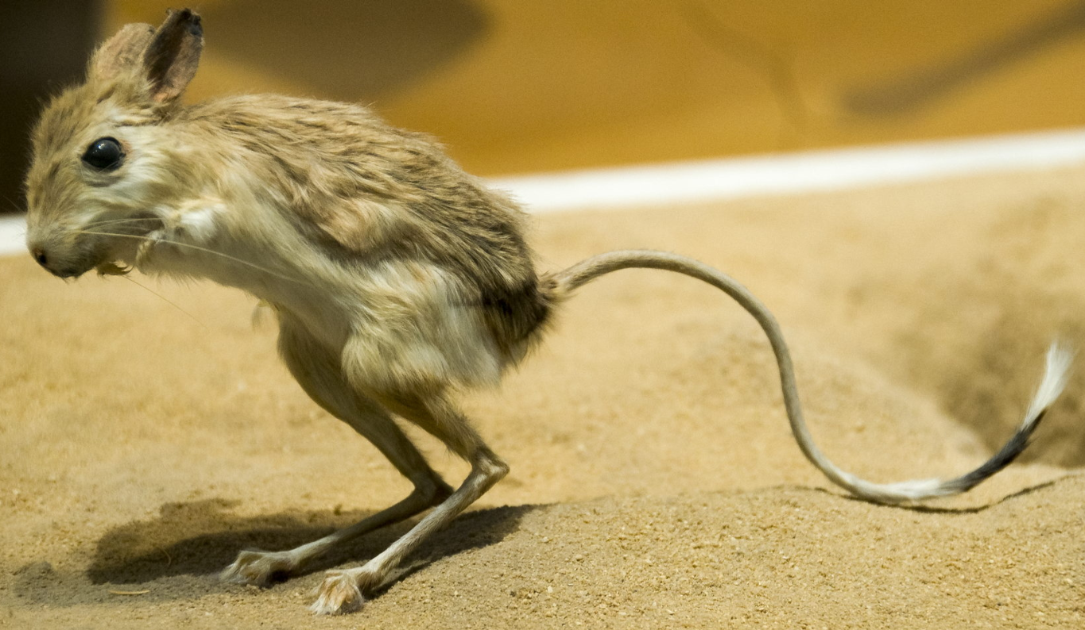

# Question 22 [35pts]

What is the difference in Celsius degrees between the Earth and the Moon at a depth of 500km?

# Question 23 [10pts]

What am I? (more specific then a giant ass turtle)

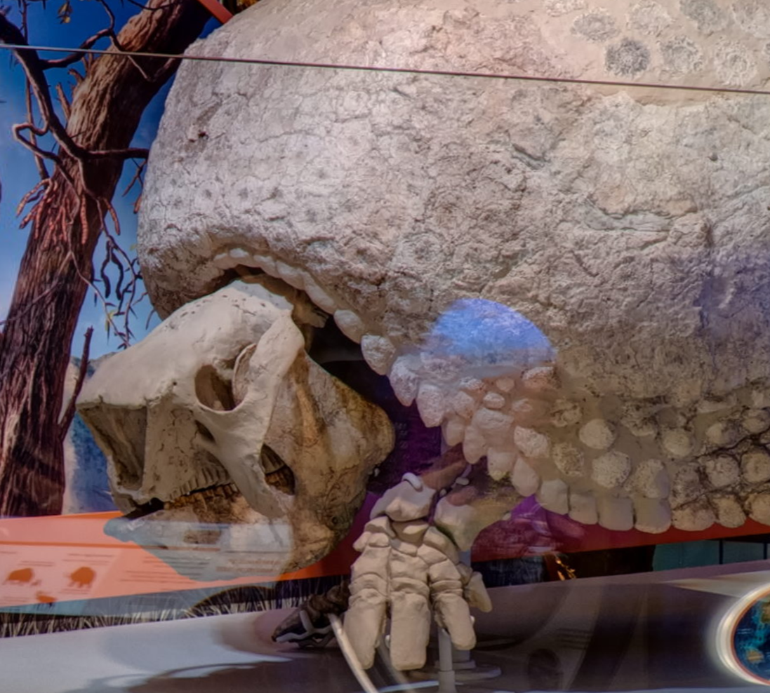

# Question 24 [15pts]

What continent does the Tayra live in?

# Question 25 [10pts]

What sound amplifying system is found only in mammals?

# Question 26 [5pts]

Take a picture of the famous Hope Diamond.

# Question 27 [60pts]

What am I worth in American dollars?

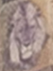

# Question 28 [5pts]

How many calories in the Kids’ Favorite Hot chocolate?

# Question 29 [20pts]

Homo _________________

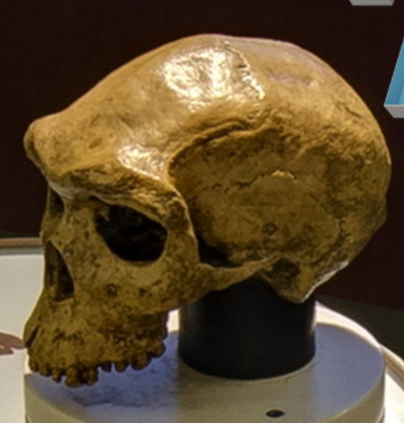

# Question 30 [15pts]

Mr. and Mrs. Jeffery Meyer are what?

# Question 31 [30pts]

Humans had a huge impact on earth species, what percentage of animals over 110 lbs went extinct in Australasia between 50,000 and 40,000 years ago? Name one.

# Question 32 [10pts]

What were the first organisms on earth?

# Question 33 [15pts]

What year was “Indonesia’s Java Man” discovered?

# Question 34 [20pts]

What am I?

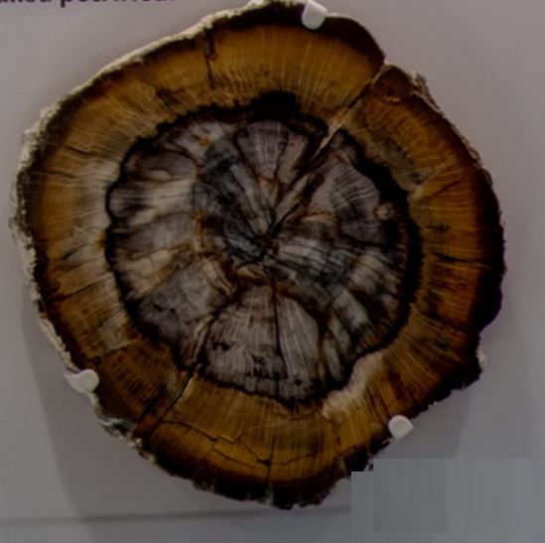

# Question 35 [5pts]

Take a picture of Lucy.

# Question 36 [10pts]

How many species of butterfly lived 170 million years ago?

# Question 37 [15pts]

I’m part of a beautiful painted house from British Columbia, can you name the culture that made me?

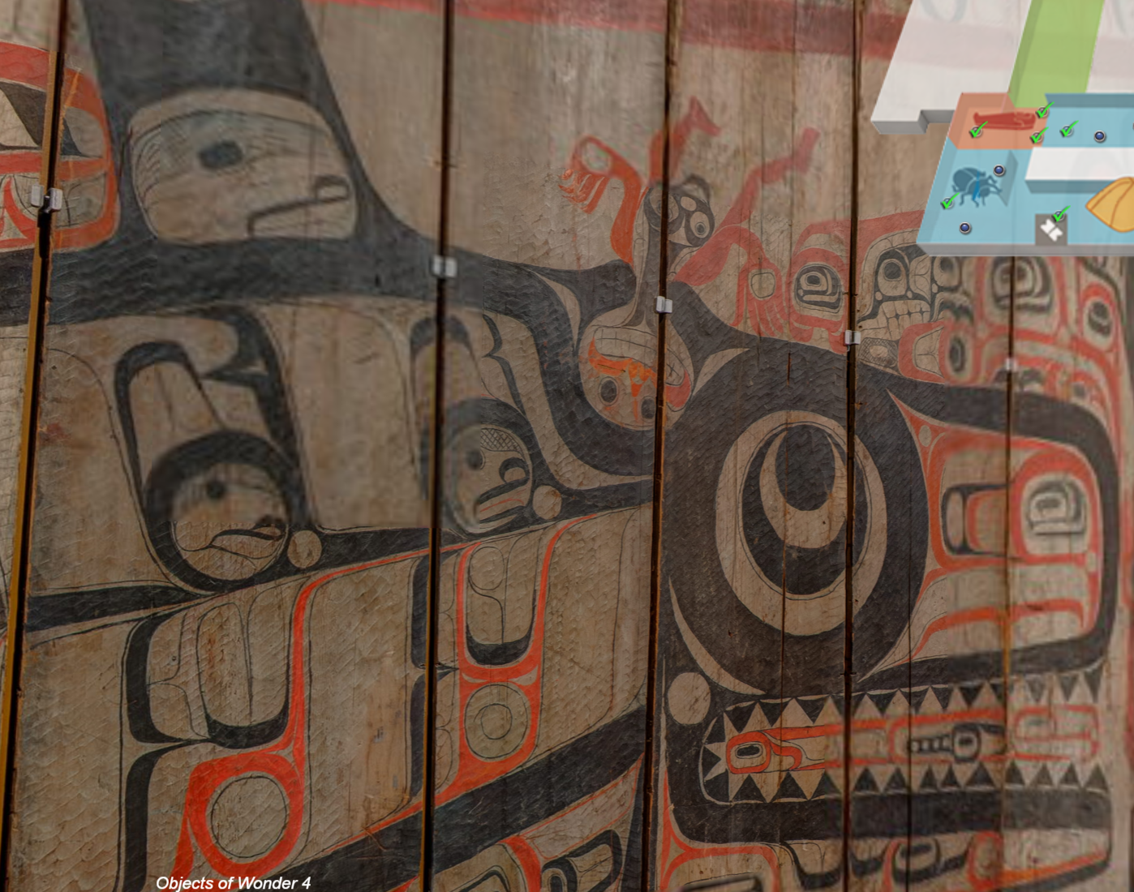

# Question 38 [70pts]

I’m red and delicious, real but not and I hang out with the Earth.

Take a picture of me.

# Question 39 [10pts]

What is the species of this “sea butterfly”?

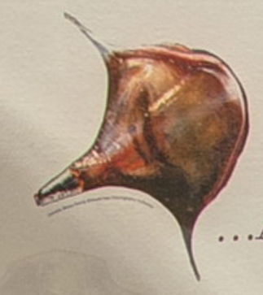

# Question 40 [10pts]

What is my name in native Swahili?

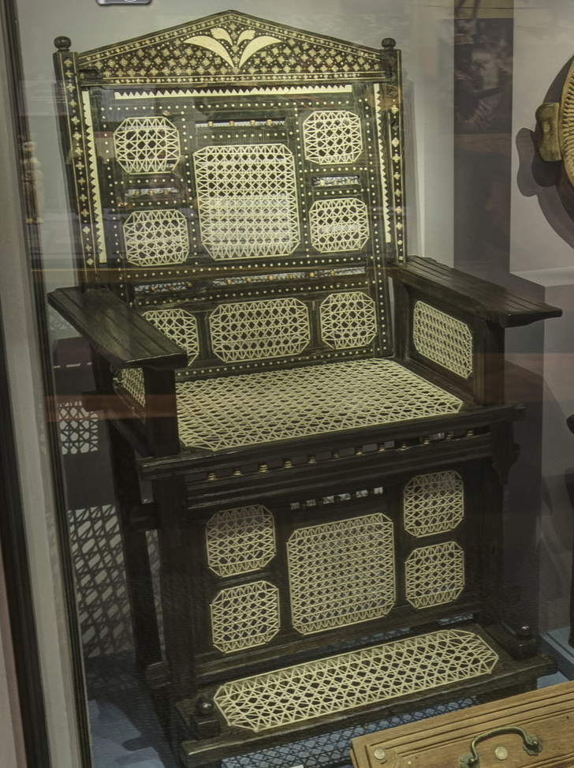

# Question 41 [15pts]

I’m famous for doing what in 1938?

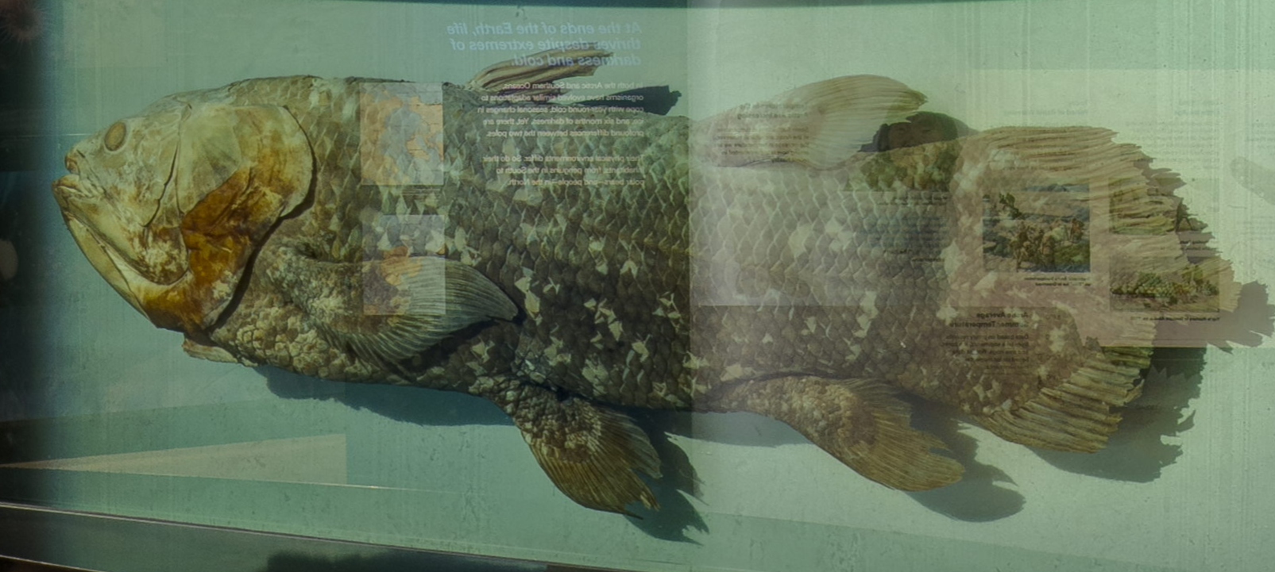

# Question 42 [15pts]

Take a picture of a four-tusked elephant.

# Question 43 [10pts]

I might look like an airplane but what am I truly?

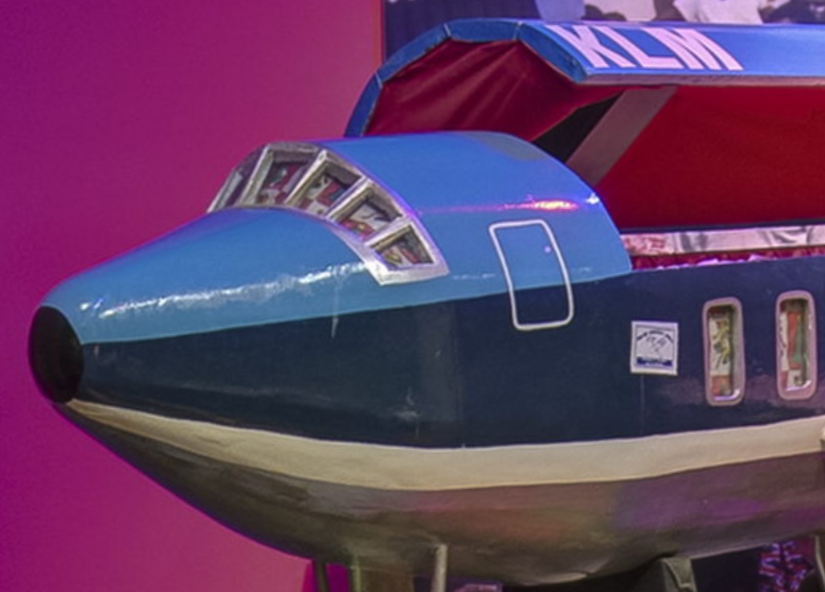

# Question 44 [5pts]

What hall of the museum do I live in?

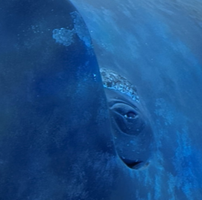

# Question 45 [30pts]

Take a picture of Smilosuchus skeleton.

# Question 46 [40pts]

I’m painted with a unique yellow color.

I’m folded up.

I’m in a place of learning.

I’m #5.

Take a picture.

# Question 47 [10pts]

What species am I?

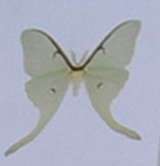

# Question 48 [20pts]

No, I’m not a Kiwi grown in Picassos garden, I’m a rock found in what country?

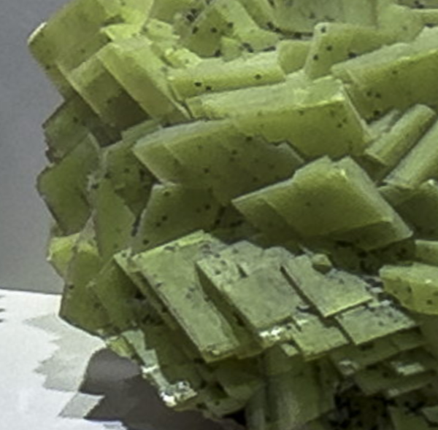

# Question 49 [60pts]

I AM NOT A _________

# Question 50 [10pts]

Take a picture of a Polar Bear.

# Question 51 [5pts]

Take a picture of a Giant Squid.

# Question 52 [52pts]

I am “nested among mountains and sea”?

Please take a picture of me.

# Question 53 [5pts]

Take a picture of a Cardinal.

# Question 53 [25pts]

3 sentences one word:

Black ______

______ lake

The Trumpet of the _____

Take a picture of me.

# Question 54 [80pts]

2 words:

Word 1 = I am alive without breath and cold as death. I am never thirsty but always drinking. What am I?

Word 2 = I'm black, use and build tools, throw funerals for dead relatives, carry messages, and starred in a very famous TV show with an extra eye.

Take a picture of me.